Assignment 6: Resistance and Capacitance
- Complete the Table for the following circuit:

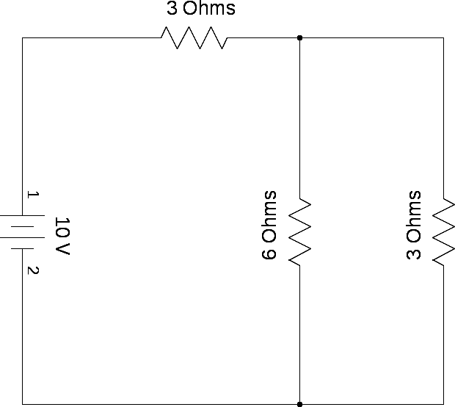

V_{src} | I_{src} | R_{eq}
V₁ | I₁ | R₁
V₂ | I₂ | R₂
V₃ | I₃ | R₃

- Complete the table for the following circuit:

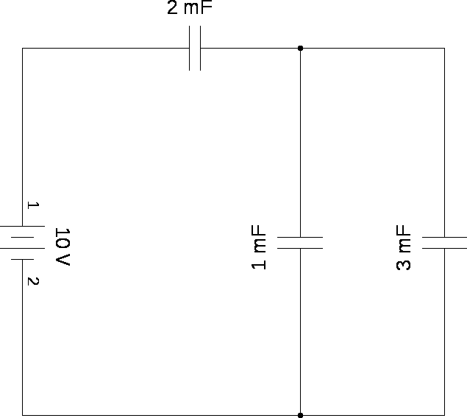
V_{src} | Q_{src} | C_{eq}
V₁ | Q₁ | C₁
V₂ | Q₂ | C₂
V₃ | Q₃ | C₃
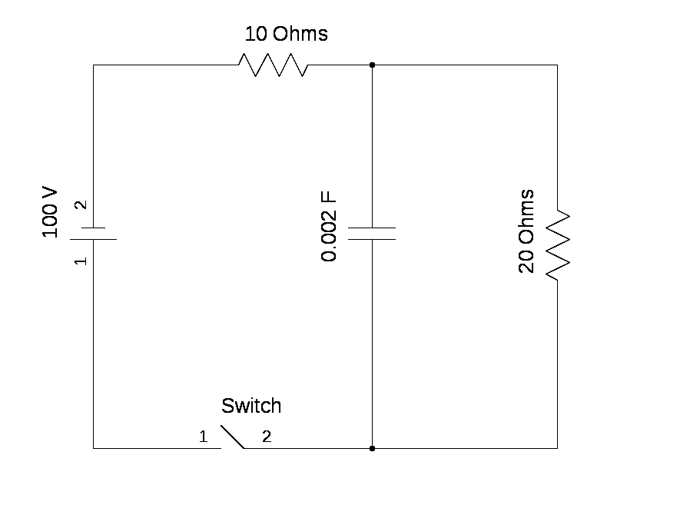
- A circuit is configured as shown in the diagram above. Initially, the capacitor has no charge. The switch is closed and the capacitor is allowed to charge.
  - What is the voltage of the 20 Ohm Resistor?

  - What is the voltage of the Capacitor?

  - What is the charge stored by the capacitor?

  - What is the potential energy of the capacitor?

  - What is the equivalent impedance of the circuit?

